Métier description report

Josefine Egekvist, DTU Aqua

02 maj, 2019

## Region: North Sea and Eastern Arctic

## Métier: OTB_DEF_>=120_0_0 , years: 2015,2016,2017

Data source: RDB CE and CL data

**Number of trips by flag countries: BEL, NLD, DEU, ENG, POL, PRT, DNK, SCT, SWE, ESP, IRL, NIR, FRA, LVA, EST**

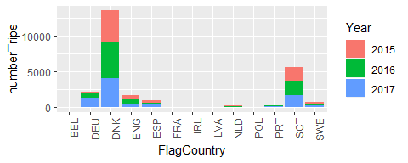

**Top 10 species landed by métier. The rest are summarised in “Other species”. Average yearly landings during the period 2015,2016,2017** 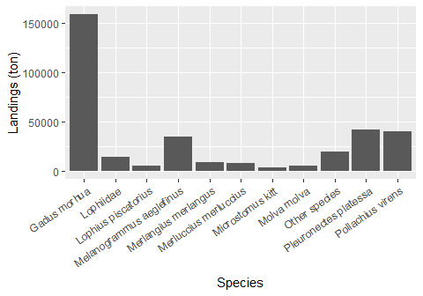

**Number of trips by vessel length group:**

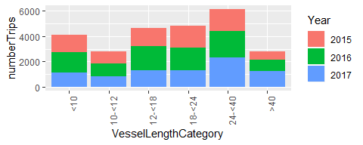

**Seasonal pattern of fishing activity: number of trips by quarter**

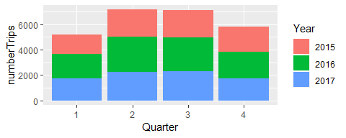

**Days at Sea by ICES rectangle, yearly average 2015-2017** 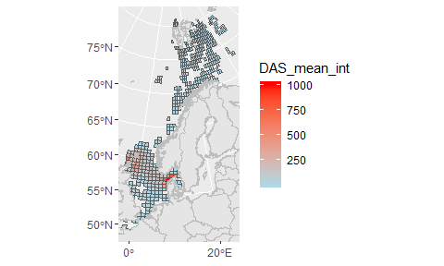

**Comments:**